MiSim Installation and Configuration Guide

Version 1.0

Author: Santhosh Kumar Kasa &

Sumit Bafna

**Installation and Setup**

1. Run setup.exe.

2. It is strongly recommended to not change the default installation path, unless you have a strong reason to do so.

3. If you haven’t changed the installation path earlier, then go ahead and click Finish. If you **have changed** the default installation path, then uncheck the checkbox and click finish.  
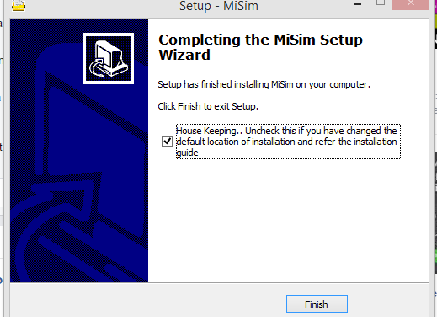

Ignore the below steps and go to step 4 if you have not changed the installation path.

* The house keeping runs a Batch script to set python path. By default the batch script is written assuming that installation path has not changed.
* In order to set the correct python path, go to the folder where it is installed and locate the “Post_Install.bat” script. Edit the script with the correct location and run the script.

4. Now, the MiSim is installed. Create a folder called logs anywhere on your file system. (On my machine, I have created it at C:\logs).

5. Open file C:\Program Files (x86)\MiSim\pxyll.cfg in a notepad and modify *path* variable and paste the path of the folder you created. This is the only manual activity you need to do at the time of installation.

Windows will not facilitate editing files in the Program files folder. So you may need to copy it to desktop and over write the pyxll.cfg file in the MiSim installation folder

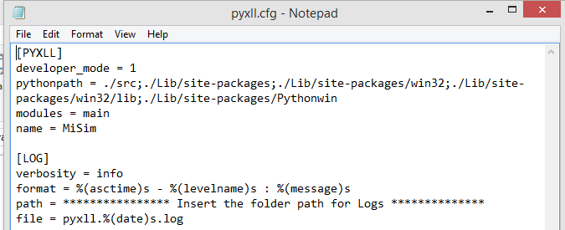

After these steps are complete, open Microsoft Excel and perform the following steps:

1. Click on File 🡪 Options. This will open the Excel Options Menu.

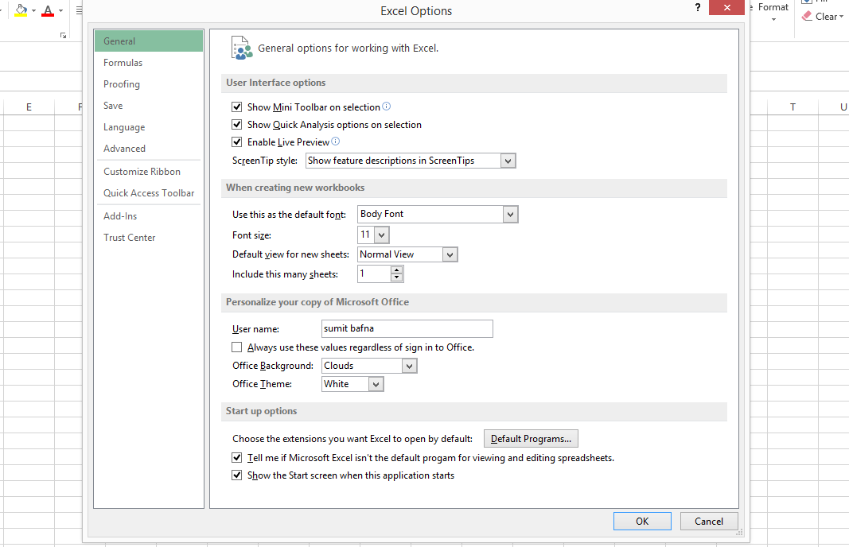

1. Click on Add-Ins.
2. Make sure that Excel Add-Ins is selected in the Manage drop-down and then click Go

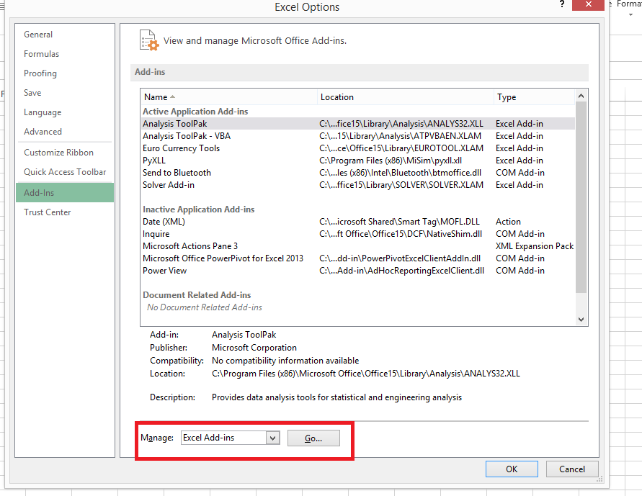

1. In the Add-Ins pop-up click on Browse and locate pxyll.xll. After installation of MiSim software, the default location should be C:\Program Files (x86)\MiSim. After selecting the file a new add-in named PyXLL will be added as shown below. Click OK and **Restart** Excel

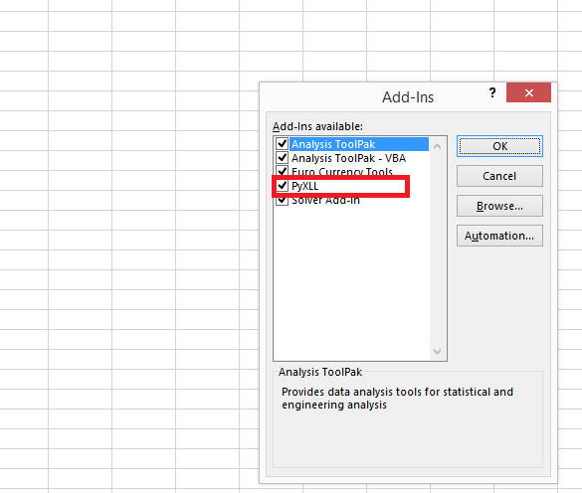

**Removing MiSim:**

In order to remove MiSim, find a “unins000.exe” in the MiSim installation folder (default: C:\Program Files (x86)\MiSim) and double click on the file. This will remove the MiSim completely.

Once, the execution is complete, delete the MiSim folder (if any traces are still present).